ASSIGNMENT 3
# ============================================
# Name: Himani Tyagi
# Course: Image Processing & Computer Vision
# Assignment: Medical Image Compression & Segmentation
# ============================================
import cv2
import numpy as np
import os
# ---------- RLE Compression ----------
def rle_encode(image):
pixels = image.flatten()
encoded = []
prev = pixels[0]
count = 1

for pixel in pixels[1:]:
if pixel == prev:
count += 1
else:
encoded.append((prev, count))
prev = pixel
count = 1
encoded.append((prev, count))
return encoded

def compression_ratio(original, encoded):
original_size = original.size
compressed_size = len(encoded) * 2
return original_size / compressed_size
# ---------- Segmentation ----------
def segmentation(image):
_, global_thresh = cv2.threshold(image, 127, 255, cv2.THRESH_BINARY)
_, otsu_thresh = cv2.threshold(image, 0, 255, cv2.THRESH_BINARY + cv2.THRESH_OTSU)
return global_thresh, otsu_thresh
# ---------- Morphology ----------
def morphology(image):
kernel = np.ones((3,3), np.uint8)
dilation = cv2.dilate(image, kernel, iterations=1)
erosion = cv2.erode(image, kernel, iterations=1)
return dilation, erosion
# ---------- Main ----------
img = cv2.imread("OIP.jpg", 0)
encoded = rle_encode(img)
ratio = compression_ratio(img, encoded)
g, o = segmentation(img)
d, e = morphology(o)
os.makedirs("outputs", exist_ok=True)
cv2.imwrite("outputs/original.jpg", img)
cv2.imwrite("outputs/global.jpg", g)
cv2.imwrite("outputs/otsu.jpg", o)
cv2.imwrite("outputs/dilation.jpg", d)
cv2.imwrite("outputs/erosion.jpg", e)
print("Compression Ratio:", ratio)
print("Storage Saving (%):", (1 - 1/ratio) * 100)
INPUT IMAGE
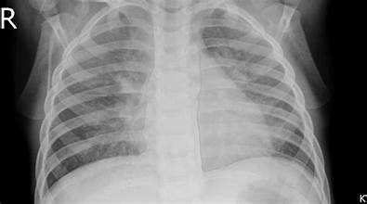
OUTPUT IMAGE
(a)otsu image
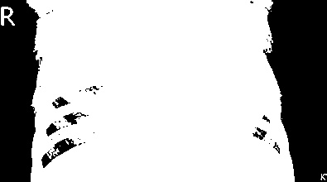

(b) global image
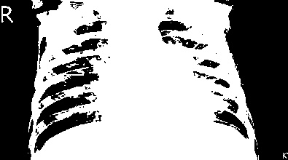
(c)erosion image
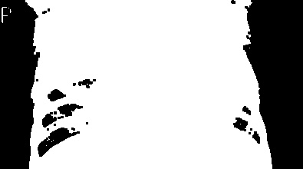
(d) dilation image
